AP Computer Science Principles: 2023

Dessa Shapiro

<https://apcentral.collegeboard.org/media/pdf/ap-csp-student-task-directions.pdf>

3a**.**

This program, created using Python, tests people on their basic math skills such as addition, subtraction, multiplication, and division, and includes a timer so people can improve their quick problem-solving skills.

The video shows the user choosing the normal difficulty which displays addition, subtraction, and multiplication. The user chooses 30 questions and is redirected to choose within the range, they then choose 5 questions. They are shown each question after answering the previous one, getting one incorrect and 4 correct. They are shown their results and choose to replay incorrect questions. After answering they chose to quit playing.

The user inputs the number of questions they wish to answer and the program outputs that number of questions if it is within the given range. After answering each question with a numerical input the program's output displays whether their answer is correct or incorrect. Once all problems have been answered, the program outputs the correct-to-incorrect answer ratio and an accuracy percentage.

3b.

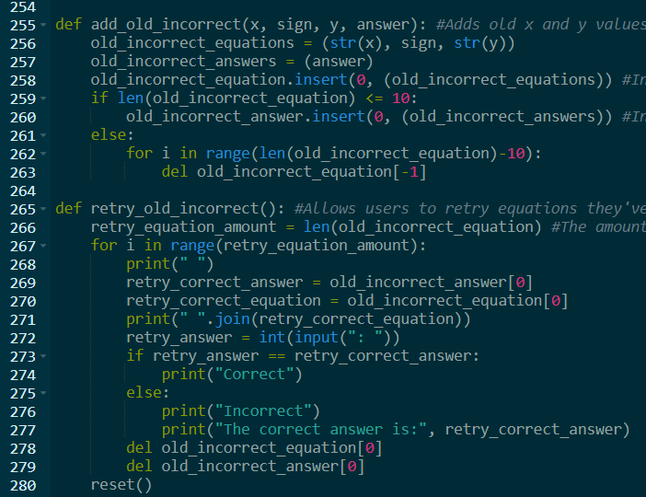



The list “old_incorrect_equation” stores the x and y values from the questions the user got incorrect. This list allows the program to combine three values, x, y, and the mathematical sign used in the question by adding a variable that combines those values before they are stored in the list. The list is used when the user chooses to retry their incorrect answers. The program takes the first value of the list, and displays it by setting the value as a new variable. It later deletes that value so that the equation representing the first value updates for each iteration of the for loop until the last 10 incorrect questions are answered. This list is necessary for the program to function, without it, there would be no way to store a large number of equations and match them with the correct answers. Since the x and y values alternate randomly for each equation and have different parameters for different levels, it would be difficult to store them in an organized way without this list. Having this list is the only way to limit the number of redo problems to 10, without it I would have had to input each saved equation as a different variable and function which would create unnecessary code.

3c.

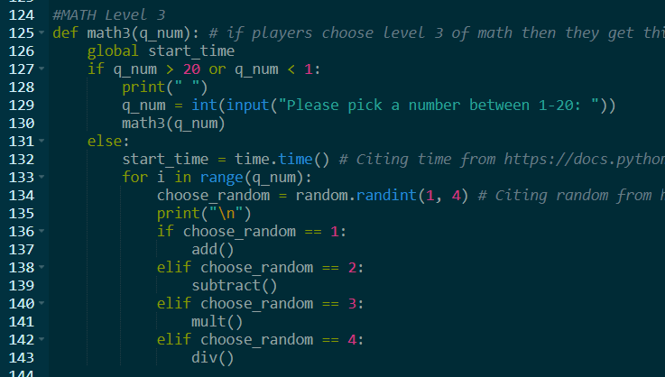

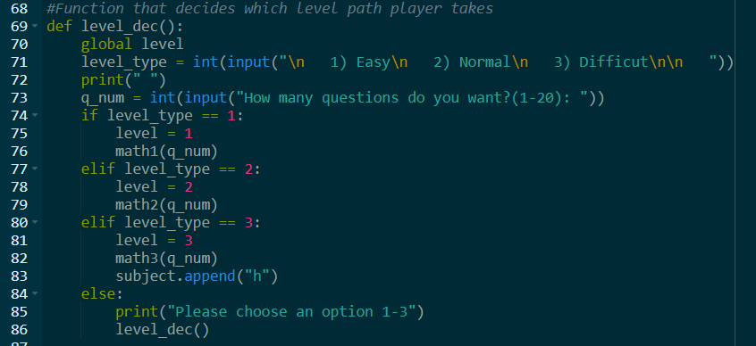

The procedure math3 is the third and most difficult level the user has the option to choose. The function is called at the beginning of the program and is the only level that includes the division operation. This function has the most complex questions since it broadens the range of numbers for each operation function. It adds to the diversity of the overall program and gives the user more opportunities to learn and improve their mathematical skills. The program implements sequencing by using the parameter q_num to check if the number falls into the correct range from 1 to 20. If the number falls outside the range the program asks the user to input a number in the range by redefining the variable q_num and then redirects back to math3. If the parameter q_num is within the range, the timer begins and the questions are displayed. The program begins to iterate the questions using a for loop with the q_num parameter so that the chosen number of questions is displayed. The type of questions is decided when the program randomly selects which of the four mathematical operations will be chosen. A variable is assigned with the value of a randomly selected value between 1 and 4, so for each iteration of the for loop the value changes value. Each number is aligned with a different operation function(addition, subtraction, multiplication, or division).

3d.

math3 is called in the function level_dec when the user gets to choose the level of difficulty.

math3 is called within the function math3 when a specific condition is met.

In the function level_dec, the user has the option to input the number 1, 2, or 3 depending on the level they want(1 = easy, 2 = normal, and 3 = difficult). When the user enters 3, the condition to call math3 is met.

The function is called within math3 when the parameter of the function(q_num) is outside the given range from 1-20. The user is asked to redefine the parameter value(q_num), and then the procedure calls math3.

When the function is called it moves to execute the questions if the parameter value defined in the level_dec function is within range, or it moves to redefine that value if the number is outside the range.

When the function is called it automatically redirects the user to restart the math3 function with the new parameter value.